1. **Damped Oscillator**
   1. **AIM**

To observe the oscillation of spring-mass system in the presence of damping.

To compare the damping effect of different liquid mediums.

* 1. **PRINCIPLE**

For a damped oscillation, energy is lost due to the resistive forces acting on the system such as friction, viscosity etc. This loss of energy causes an exponential decay in the amplitude. The equation of motion is given by,

$$x(t)=A_{0}e^{-γt}\sin{(ωt)}$$

Where

γ = $\frac{b}{2m}$- damping factor

M – mass of the oscillator.

* 1. **EQUIPMENTS REQUIRED**

Table I: Equipments and items required for performing the experiment.

|  |  |  |
| --- | --- | --- |
| **S. No.** | **Required item** | **Utility** |
| 1 | PC | To read the data |
| 2 | Data-logging interface | To analyze raw data from sensor |
| 3 | Rotary Sensor | To collect raw data |
| 4 | Spring(s) and mass set | For the spring-mass system |
| 6 | Retort stand | To hold the Assembly |
| 7 | Beakers | For holding the damping medium |
| 8 | Different medium | The produce Damping |

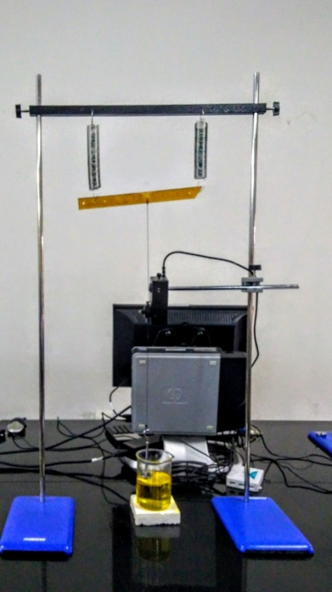

**Fig - 1. Damped Oscillator Apparatus**

* 1. **PROCEDURE**

Table II : Details of Physical quantities to be measured

|  |  |  |  |  |  |  |
| --- | --- | --- | --- | --- | --- | --- |
| S.No | Physical quantity | Independent /  Dependent | Measured  With | Measuring instrument’s | | |
| Minimum | Maximum | Least count |
| 1 | time | Independent | Logger Pro | 0 |  |  |
| 2 | Angle | Dependent | Logger pro |  |  |  |
| 3 | mass | independent | Weighing machine |  |  |  |

* 1. Arrange retort stand bases, Rods and horizontal Beam as shown in fig - 1.
  2. Hang the springs on the stand and attach the horizontal Teflon strip.
  3. Tie a thread at the center of the Teflon sheet.
  4. Fix the rotary motion sensor such that the thread just touches the outer side of the Rotary motion sensor.
  5. Pass the thread over the larger pulley
  6. Hang weights about 100gm using a weight hanger and ensure that the mass is completely immersed in a medium taken in a beaker.
  7. Connect the data interface with rotary motion using a mini USB cable to lab mate.
  8. Select rotary motion sensor and distance mode distance on it.
  9. Set sampling mode to auto sampling and sampling rate to 1000 samples per second.
  10. Start the play button on left top of the screen and simultaneously pull the weight down and release it.
  11. The software will start plotting the damping wave.
  12. This is a plot of amplitude against time.
  13. Note down the values of consecutive maximum displacements along with their time coordinates.
  14. Repeat the steps for different mediums.
  15. Plot a graph of $\ln{\frac{A_{i}}{A_{0}}}$ v/s Time and obtain the value of damping factor using the slope.

*Table III : Observation*

|  |  |  |  |  |  |
| --- | --- | --- | --- | --- | --- |
| **S.No.** | **Time T** | **T - T0** | **Ai** | **Reduction ratio** | |
| $$\frac{A_{i}}{A_{0}}$$ | $$\ln{{A_{i}}/{A_{0}}}$$ |
|  | **S** | **S** | **cm** |  |  |
| initial |  |  |  |  |  |
| 1 |  |  |  |  |  |
| 2 |  |  |  |  |  |

* 1. **STUDY QUESTIONS**
     1. Is damping factor constant for a given medium or for a given damped system ?
     2. what are some examples where damping is useful?
     3. Are there any mediums which have low density but high damping factor? (hint - Non-Newtonian Fluids)
     4. Can the extent of Damping be reduced by changing the shape of the oscillator?
  2. **FURTHER SCOPE OF EXPERIMENTS**
     1. Find the ratio of consecutive amplitudes and plot them on your favorite mathematical tool. Try to reason out the exponential reduction of the ratios.
     2. How is damping coefficient related to the viscosity of the liquid.
  3. **PRECAUTIONS**
     1. Ensure that the springs, thread and masses are in the same plane.
     2. The mass should be completely immersed in the medium through out the motion.
     3. Adding too much mass to the system will make the masses hit the bottom of the beaker which will tamper the reading.
  4. **SOURCES OF ERROR**
     1. Motion not happing in a single plane.
  5. **THEORY**

**3.11 FURTHER READING AND RESOURCES**

**Text books**

A P French pages 3-16, 19-28 and 41-70.

Bekefi & Barrett pages 1-21 and 37-47.

George King-Vibrations and Waves 33-37.

**Java apps/apps**

**iitk.vlab.co.in,. (2012). Damped Harmonic Motion. Retrieved 6 May 2018, from iitk.vlab.co.in/?sub=27&brch=236&sim=1210&cnt=2**

**Videos**

https://www.youtube.com/watch?v=HRcjtVa1LfM

* + 1. https://www.youtube.com/watch?v=pnfZjGIyKVw 8.03 - Lect 2 - Beats, Damped Free Ocillations, Quality Q